Parth Babbar

Investment banking functions & Mergers and acquisitions (M&A)

Investment Banking Functions:
Investment banking is an important aspect of the US financial industry, with a focus on capital markets, corporate finance, and consulting services. Investment banks support big, complicated financial transactions by performing underwriting, acting as middlemen between securities issuers and the investing public, and offering strategic advice services for mergers, acquisitions, and other types of transactions.
Key Functions:
- Underwriting: Investment banks assist firms obtain cash by underwriting and issuing securities such as stocks and bonds. This includes valuing the securities, purchasing them from the issuer, and selling them to individual or institutional investors.
- Advisory Services: They advise on mergers, acquisitions, restructurings, and other financial concerns. This involves assisting corporations in identifying possible targets or purchasers, negotiating terms, and structuring transactions.
- Sales and Trading: Investment banks purchase and sell securities on behalf of their clients and for their own benefit. They offer liquidity and enable market making in a variety of financial products.
- Asset Management: They provide asset management services, managing investments for a wide range of clients, including institutions and individuals.
- Research: We provide research reports and analysis on numerous industries, businesses, and financial markets to assist customers in making educated investment decisions.
Challenges:
- Regulatory Compliance: Investment banks are subject to severe regulatory standards, which may be costly and hard to administer.
- Market Volatility: Financial market fluctuations might have an influence on underwriting and trading profitability.
- Technological Disruption: Fintech technologies are transforming the sector, creating both possibilities and challenges.
- Talent Retention: Attracting and maintaining top talent is vital, but difficult due to competition and demanding work situations.
Solutions:
- Regulatory Compliance: To succeed in the regulated financial industry, institutions must create effective compliance processes, invest in regulatory technology (RegTech) for efficient monitoring, and maintain good connections with regulators. These tactics assure regulatory compliance, improve operational efficiency, and promote openness, all of which are critical for long-term growth and confidence within the regulatory environment.
- Market Volatility: To flourish in volatile markets, firms should diversify their income streams, implement effective risk management methods, and use advanced analytics to predict market trends. These strategies promote resilience, proactive decision-making, and long-term growth in competitive contexts.
- Technological Disruption: To flourish, businesses should invest in technology, collaborate with fintech companies, and emphasize digital transformation. These actions increase efficiency and improve the client experience, supporting long-term growth and a competitive edge.
- Talent Retention: To retain talent, prioritize competitive salary, a pleasant culture, professional development, and activities that promote work-life balance. These pillars contribute to employee happiness and corporate success.
Statistics:
- Market Size: The US investment banking sector was valued at $79.5 billion in 2023.
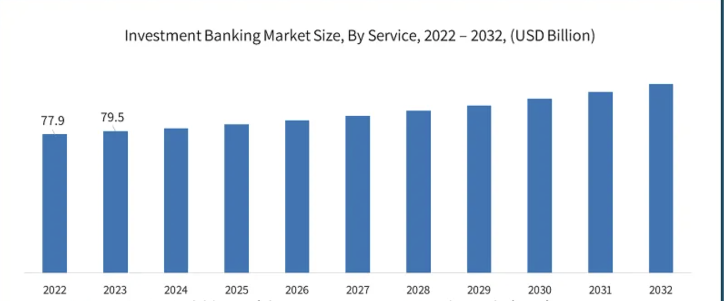
- Revenue Breakdown:
1.Underwriting accounts: 30%
2.Advisory services: 25%.
3.Sales and Trading: 35%.
4.Asset Management: 10%.
- Employment: The sector employs around 200,000 people.
- Key Players: Goldman Sachs, JPMorgan Chase, Morgan Stanley, Bank of America Merrill Lynch, and Citigroup are among the industry leaders.
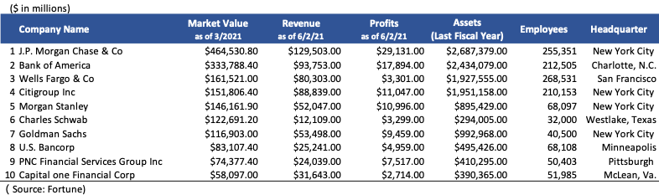
Conclusion:
Investment banking is a critical component of the US financial system, enabling capital formation, offering strategic guidance, and increasing market liquidity. Despite obstacles such as regulatory scrutiny, market volatility, and technology upheaval, investment banks continue to innovate and adapt. Investment banks can sustain development and fulfil client expectations in a constantly changing global market by embracing digital transformation, developing people, and efficiently navigating regulatory frameworks.
Mergers and Acquisitions (M&A):
Mergers and acquisitions (M&A) are important methods for business expansion, diversification, and competitive advantage. The United States is one of the world's largest and most active merger and acquisition markets, with deals spanning several industries and sectors.
Process:
- Identification and Targeting: Companies select possible acquisition or merger partners based on strategic fit, financial health, and market opportunity.
- Due Diligence: To analyse risks and rewards, a detailed examination of the target company's financials, operations, legal issues, and market position is carried out.
- Valuation and Pricing: Investment banks help determine the target firm's worth using a variety of valuation approaches such as discounted cash flow (DCF), similar business research, and precedent deals.
- Negotiation and agreement Structuring: negotiating terms and structuring the agreement, including the payment method (cash, shares, or a combination) as well as the transaction's legal and financial structure.
- Integration: Following the transaction, the attention switches to integrating the merged or acquired businesses' operations, cultures, and systems in order to create synergies and strategic goals.
Challenges:
- Value Discrepancies: Buyers and sellers' value estimates might make deal completion difficult.
- Regulatory Obstacles: Antitrust laws and other regulatory clearances can slow or prevent M&A deals.
- Cultural Integration: Post-merger integration of business cultures can be difficult, affecting employee morale and retention.
- Synergy Realization: Achieving the predicted synergies and financial advantages from M&A transactions can be challenging.
Solutions:
- Valuation Discrepancies: When conducting commercial transactions, it is necessary to use a variety of valuation methodologies, negotiate transparently, and consider earn-outs or contingent payments. These techniques aid in generating a complete assessment, building confidence between parties, and bridging possible value gaps, resulting in fair and strategic agreements.
- Regulatory Obstacles: Early involvement of legal and regulatory specialists, detailed antitrust risk assessments, and full filings can help speed up approvals. These stages expedite operations, reduce risks, and maintain compliance, allowing for speedier transactions and approvals.
- Cultural Integration: Develop a clear integration strategy that includes key stakeholders from both firms and prioritizes open communication and cultural alignment. These procedures are required for a successful integration and synergy.
- Synergy Realization: Set realistic synergy targets, continuously evaluate integration progress, and adapt methods as needed to guarantee goals are met. These activities optimize integration efforts, increasing efficiency and outcomes.
Statistics:
- Market Size: In Q1 2023, the US M&A market is expected to approach $1.3 trillion in transaction volume.
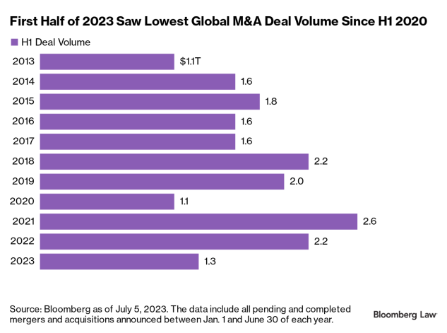
- Sector Breakdown:
1.Technology: 30%
2.Healthcare: 20%
3.Financial Services: 15%
4.Consumer Goods: 10%
5.Industrial: 10%
6.Others: 15%
- Deal Size: The average transaction size in the United States was over $100 million, with mega-deals topping $10 billion.
- Cross-Border M&A: About 25% of US M&A deals involved foreign corporations.
Conclusion:
Mergers and acquisitions play an important role in developing company strategy, promoting development, and driving industry consolidation in the United States. While issues like as value disparities, legal barriers, cultural integration, and synergy realization are common, strategic preparation and rigorous execution can limit these risks. Companies may optimize value creation and achieve long-term success in the dynamic US market by employing rigorous due diligence, participating in transparent negotiations, and prioritizing post-merger integration.
Conclusion:
Investment banking and M&A operations are critical to the US financial environment, enabling firms to develop, innovate, and gain a competitive edge. Regardless of the problems, strategic methods and solutions can help limit risks and capitalize on opportunities. To compete in this fast-changing climate, investment banks and M&A firms must constantly adjust to regulatory, market, and technology shifts.

